
CHARLES DARWIN UNIVERSITY
Sydney Campus
PRT585/681
Software Engineering: Practice
──────────────────────────────────────────
Software Requirement Specification
SUBMITTED BY

Amsh Shrestha
S394695
Devi Maya
S388017
Shanti Moktan
S395240

Introduction

Purpose
This document specifies the functional and non-functional requirements for SplitSync, a group-based expense-splitting Progressive Web Application. It is intended to guide development, testing, and validation of the system for its stakeholders.

Scope
SplitSync enables groups of users (e.g. roommates, travel groups) to track, split, and settle shared expenses in a synchronised, group-based environment. The application is explicitly group-oriented, it does not support individual/personal expense tracking outside a group context.
Features:
- Group creation and membership management
- Expense entry, editing, viewing, and removal
- Split configuration: equal, unequal, and percentage-based
- Receipt/photo attachment to expenses
- Expense history per group
- Balance visibility (amount owed/owing) per group
- Record settlement of unpaid amounts in a group
- Email notifications for unpaid balances
- Recurring expenses management
- Activity tab (group activity log)
Out of scope:
- Real-time payment processing (no in-app payment gateway)
- Member removal while an unsettled balance exists
- Currency conversion / multi-currency support
- Native mobile application (PWA only)
- Debt simplification/netting (settling up is individual payments)

Definitions
Spending Group/Group: a set of users sharing tracked expenses
Settlement: user- recorded entry representing payment of an owed balance between members; does not process actual payment, and does not perform debt netting/simplification

Description
SplitSync is a new, standalone system (not an extension of an existing product). It is a mobile-first responsive PWA, with a .NET backend, React frontend, PostgreSQL (Neon) database, and Cloudflare R2 for asset storage (e.g. receipt images). User authentication is handled via a third-party identity provider (IdP) Kinde, rather than self-managed credential storage.
Figure 1 shows the system context of SplitSync: the people and external systems it interacts with. Users access SplitSync through the web application, authentication is delegated to the identity provider (Kinde), and reminder emails are delivered by a third-party email delivery service.
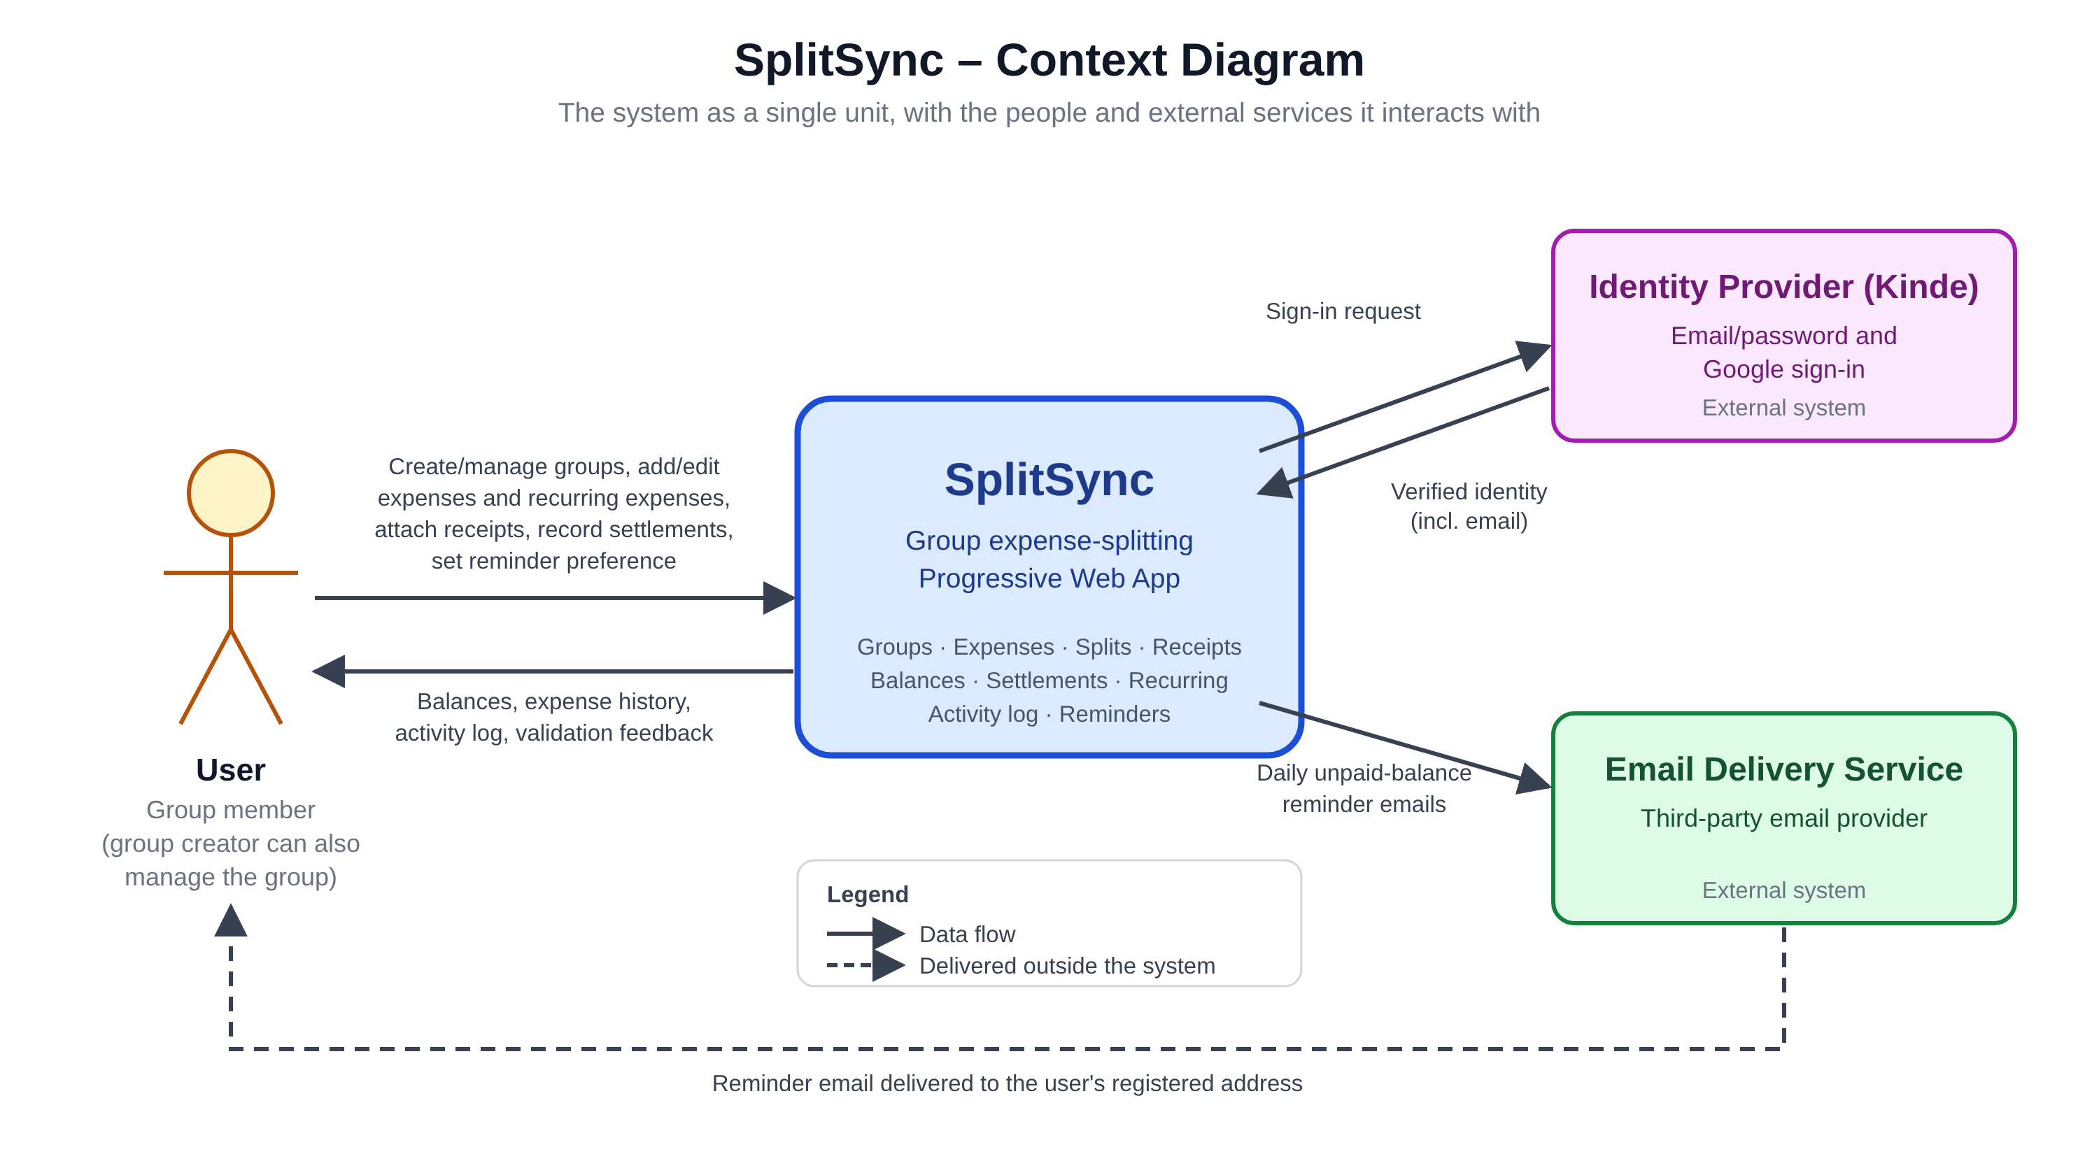
Figure 1: SplitSync context diagram

Product Function Summary
- Group lifecycle management (create, manage membership)
- Expense management (CRUD + attachments)
- Split calculation (equal/unequal/percentage)
- Balance tracking and settle-up recording
- Notifications (email)
- Recurring expense scheduling
- Activity/history logging

Operating Environment
PWA with responsive design, accessible from web browsers from both mobile and desktop.

Constraints
- Limited development resources (3-person team with part-time availability) and time (10 weeks)
- Any authenticated user may create a spending group.
- Management of an existing group is restricted to the group's creator via resource ownership. Enforced through fine-grained RBAC at the implementation level, not a separate user account type or role entity.
- Authentication and credential storage are delegated to a third-party IdP.

Assumptions
- User has valid email address
- User has stable connectivity
- Service is dependent on third-party email delivery service

Functional Requirements

Table 1: Functional requirements
FR ID | Category | Functional Requirement
FR-AUTH-01 | Authentication | The system shall allow a user to create an account
FR-AUTH-02 | Authentication | The system shall allow a user to log in
FR-AUTH-03 | Authentication | The system shall allow a user to log out
FR-AUTH-04 | Authentication | The system shall allow an authenticated user to permanently delete their account, anonymizing their historical references in expenses, settlements, and activity, provided the user has no unpaid balance in any group
FR-GROUP-01 | Spending Group | The system shall allow an authenticated user to create a new spending group
FR-GROUP-02 | Spending Group | The system shall allow the group creator to delete a spending group
FR-GROUP-03 | Spending Group | The system shall allow the group creator to edit group details
FR-GROUP-04 | Spending Group | The system shall allow the group creator to add members to a spending group
FR-GROUP-05 | Spending Group | The system shall allow the group creator to remove a member from a spending group
FR-GROUP-06 | Spending Group | The system shall allow an authenticated user to view a list of spending groups they belong to
FR-GROUP-07 | Spending Group | The system shall allow an authenticated group member to view balances between themself and other members within a spending group
FR-GROUP-08 | Spending Group | The system shall allow an authenticated group member to view a combined list of expenses and settlements within a spending group
FR-EXP-01 | Expense | The system shall allow an authenticated group member to add an expense in a spending group
FR-EXP-02 | Expense | The system shall allow an authenticated group member to edit an expense in a spending group
FR-EXP-03 | Expense | The system shall allow an authenticated group member to delete an expense in a spending group
FR-EXP-04 | Expense | The system shall allow an authenticated group member to view an expense's details in a spending group
FR-EXP-05 | Expense | The system shall allow an authenticated group member to select a split method (equal, unequal, or percentage-based) when adding or editing an expense, with all split amounts calculated to 2 decimal places and any rounding remainder from an equal split allocated sequentially to the first listed member(s) in the split
FR-EXP-06 | Expense | The system shall allow an authenticated group member to attach a receipt or photo to an expense
FR-EXP-07 | Expense | The system shall allow an authenticated group member to add a recurring expense in a spending group
FR-EXP-08 | Expense | The system shall allow an authenticated group member to edit a recurring expense in a spending group
FR-EXP-09 | Expense | The system shall allow an authenticated group member to delete a recurring expense in a spending group
FR-SETL-01 | Settlement | The system shall allow an authenticated group member to add a settlement record in a spending group
FR-SETL-02 | Settlement | The system shall allow an authenticated group member to edit a settlement record in a spending group
FR-SETL-03 | Settlement | The system shall allow an authenticated group member to delete a settlement record in a spending group
FR-SETL-04 | Settlement | The system shall allow an authenticated group member to view a settlement record's details in a spending group
FR-ACT-01 | Activity | The system shall allow an authenticated user to view a list of recent expense and settlement create, edit, and delete activity they are involved in, across all spending groups they belong to
FR-NOTIF-01 | Notification | The system shall allow an authenticated user to enable or disable email reminders for unpaid balances
FR-SYS-01 | System | The system shall send a reminder email once daily, at a fixed system-defined time, to a user's registered email address listing each spending group and amount for any unpaid balance, if the user has enabled email reminders
FR-SYS-02 | System | The system shall prevent removal of a group member who has an unpaid balance
FR-SYS-03 | System | The system shall automatically create a new expense in a spending group according to an active recurring expense's defined schedule, where 'active' means the current date falls within the template's start and end date (if set)

Use Case

Use case diagram
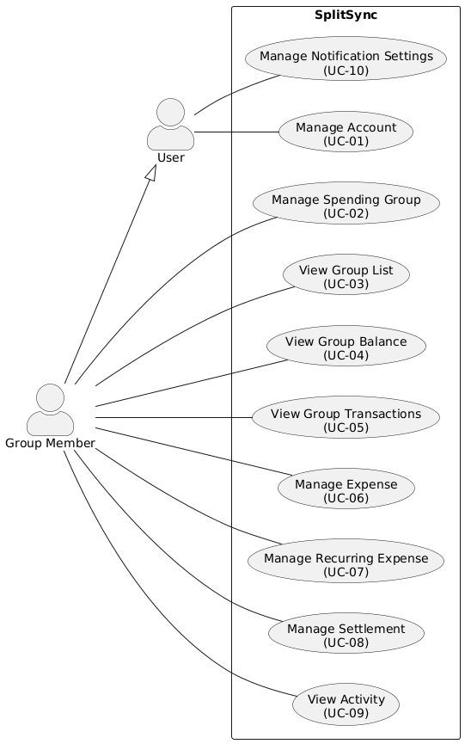
Figure 2: SplitSync use case diagram

Use case description

UC-01: Manage Account
Actor: User
Description: Allows a user to create an account, log in, and log out, via the system's identity provider (email/password or Google sign-in)
Preconditions: None (for account creation); for login/logout, actor has an existing account; for delete, actor has no unpaid balance in any group
Postconditions: Actor holds an authenticated session (create/login) or session is terminated (logout); actor's personal information is removed and historical records anonymized (delete)

Main Flow – Create Account
- Actor selects "Create Account"
- System presents sign-in method options (email/password, Google)
- Actor selects a method and provides required credentials
- System delegates credential verification to the IdP
- IdP confirms identity and returns a verified email address
- System creates a new user account linked to the verified identity
- System establishes an authenticated session for the actor

Alternate Flow — Log In
- Actor selects "Log In"
- Actor selects a sign-in method and provides credentials
- System delegates verification to the IdP
- IdP confirms identity
- System establishes an authenticated session for the actor

Alternate Flow — Log Out
- Actor selects "Log Out"
- System terminates the actor's authenticated session

Alternate Flow — Delete Account
- Actor selects "Delete Account"
- System confirms the actor's intent to delete their account
- System permanently removes the actor's personal information (e.g. name, email, credentials link)
- System anonymizes the actor's historical references in expenses, settlements, and activity across all groups (e.g. replaced with a generic identifier such as "Deleted User"), preserving the underlying records for other members' balance and history integrity
- System terminates the actor's session and account access

Exception Flows
- IdP fails to verify credentials → system denies access, returns to sign-in prompt
- Google account has no verified email → system rejects account creation, prompts actor to use email/password instead

UC-02: Manage Spending Group
Actor: Group Member
Description: Allows a group member to create a spending group, and for groups they created, edit group details, delete the group, add members, and remove members
Preconditions: Actor holds an authenticated session (for all flows); for edit/delete/add member/remove member, actor is the creator of the target group
Postconditions: A new group exists with the actor as creator (create); group details are updated (edit); group and its associated data no longer exist (delete); member list is updated (add/remove)

Main Flow – Create Spending Group
- Actor selects "Create Group"
- Actor provides group details (e.g. name)
- System creates the spending group with the actor recorded as creator
- System adds the actor as the group's first member

Alternate Flow — Edit Group Details
- Actor selects "Edit Group" for a group they created
- System verifies actor is the group's creator
- Actor updates group details
- System saves the updated details

Alternate Flow — Delete Group
- Actor selects "Delete Group" for a group they created
- System verifies actor is the group's creator
- System removes the group and its associated data

Alternate Flow — Add Member
- Actor selects "Add Member" for a group they created
- System verifies actor is the group's creator
- Actor specifies the user to add
- System adds the specified user to the group

Alternate Flow — Remove Member
- Actor selects "Remove Member" for a group they created
- System verifies actor is the group's creator
- System checks the target member's balance in the group
- System removes the member from the group

Exception Flows
- Actor is not the group's creator (edit/delete/add member/remove member) → system denies the action
- Target member has an unpaid balance (remove member) → system rejects removal (FR-SYS-02)

Notes
- Group deletion is allowed regardless of unpaid balances between members (no netting check applied on delete).
- Creator self-removal from a group is out of scope for this version.

UC-03: View Group List
Actor: Group Member
Description: Allows a user to view the list of spending groups they belong to
Preconditions: Actor holds an authenticated session
Postconditions: None (read-only)

Main Flow
- Actor navigates to the group list view
- System retrieves all spending groups the actor is a member of
- System displays the list of groups to the actor

Exception Flows
- Actor belongs to no groups → system displays an empty state

UC-04: View Group Balance
Actor: Group Member
Description: Allows a group member to view balances directly involving them within a spending group
Preconditions: Actor holds an authenticated session; actor is a member of the target group
Postconditions: None (read-only)

Main Flow
- Actor selects a spending group they belong to
- System calculates balances between the actor and each other member, based on recorded expenses and settlements
- System displays each balance directly involving the actor (e.g. amounts the actor owes to specific members, and amounts specific members owe the actor)

Exception Flows
- Actor is not a member of the target group → system denies access
- Actor has no balance with any other member → system displays an empty/zero state

Notes
- Balances between two other members that do not involve the actor (e.g. "B owes C") are intentionally excluded from this view.

UC-05: View Group Transactions
Actor: Group Member
Description: Allows a group member to view the combined list of expenses and settlements within a spending group
Preconditions: Actor holds an authenticated session; actor is a member of the target group
Postconditions: None (read-only)

Main Flow
- Actor selects a spending group they belong to
- System retrieves all expenses and settlement records within the group
- System displays the combined list, ordered by transaction date, descending

Exception Flows
- Actor is not a member of the target group → system denies access
- Group has no recorded expenses or settlements → system displays an empty state

Notes
- All expenses and settlements in the group are visible to every member, regardless of whether the actor is a party to each record.
- Ordering is by user-editable transaction date, not record creation timestamp.

UC-06: Manage Expense
Actor: Group Member
Description: Allows a group member to add, edit, delete, or view an expense within a spending group, including split method selection and receipt attachment
Preconditions: Actor holds an authenticated session; actor is a member of the target group
Postconditions: Expense is created/updated/removed within the group (add/edit/delete); no state change (view)

Main Flow – Add Expense
- Actor selects "Add Expense" within a spending group
- Actor provides expense details (mandatory: name, amount, transaction date. optional: notes); actor is recorded as the payer
- Actor selects a split method: equal, unequal, or percentage-based
- Actor selects which group members owe a share, and provides split details according to the selected method (e.g. amounts or percentages per member)
- Actor optionally attaches a receipt/photo
- System validates the expense and split details (unequal amounts must sum to the total; percentages must sum to 100%)
- System creates the expense record within the group
Figure 3 shows the activity diagram for the main flow of UC-06: Add Expense.
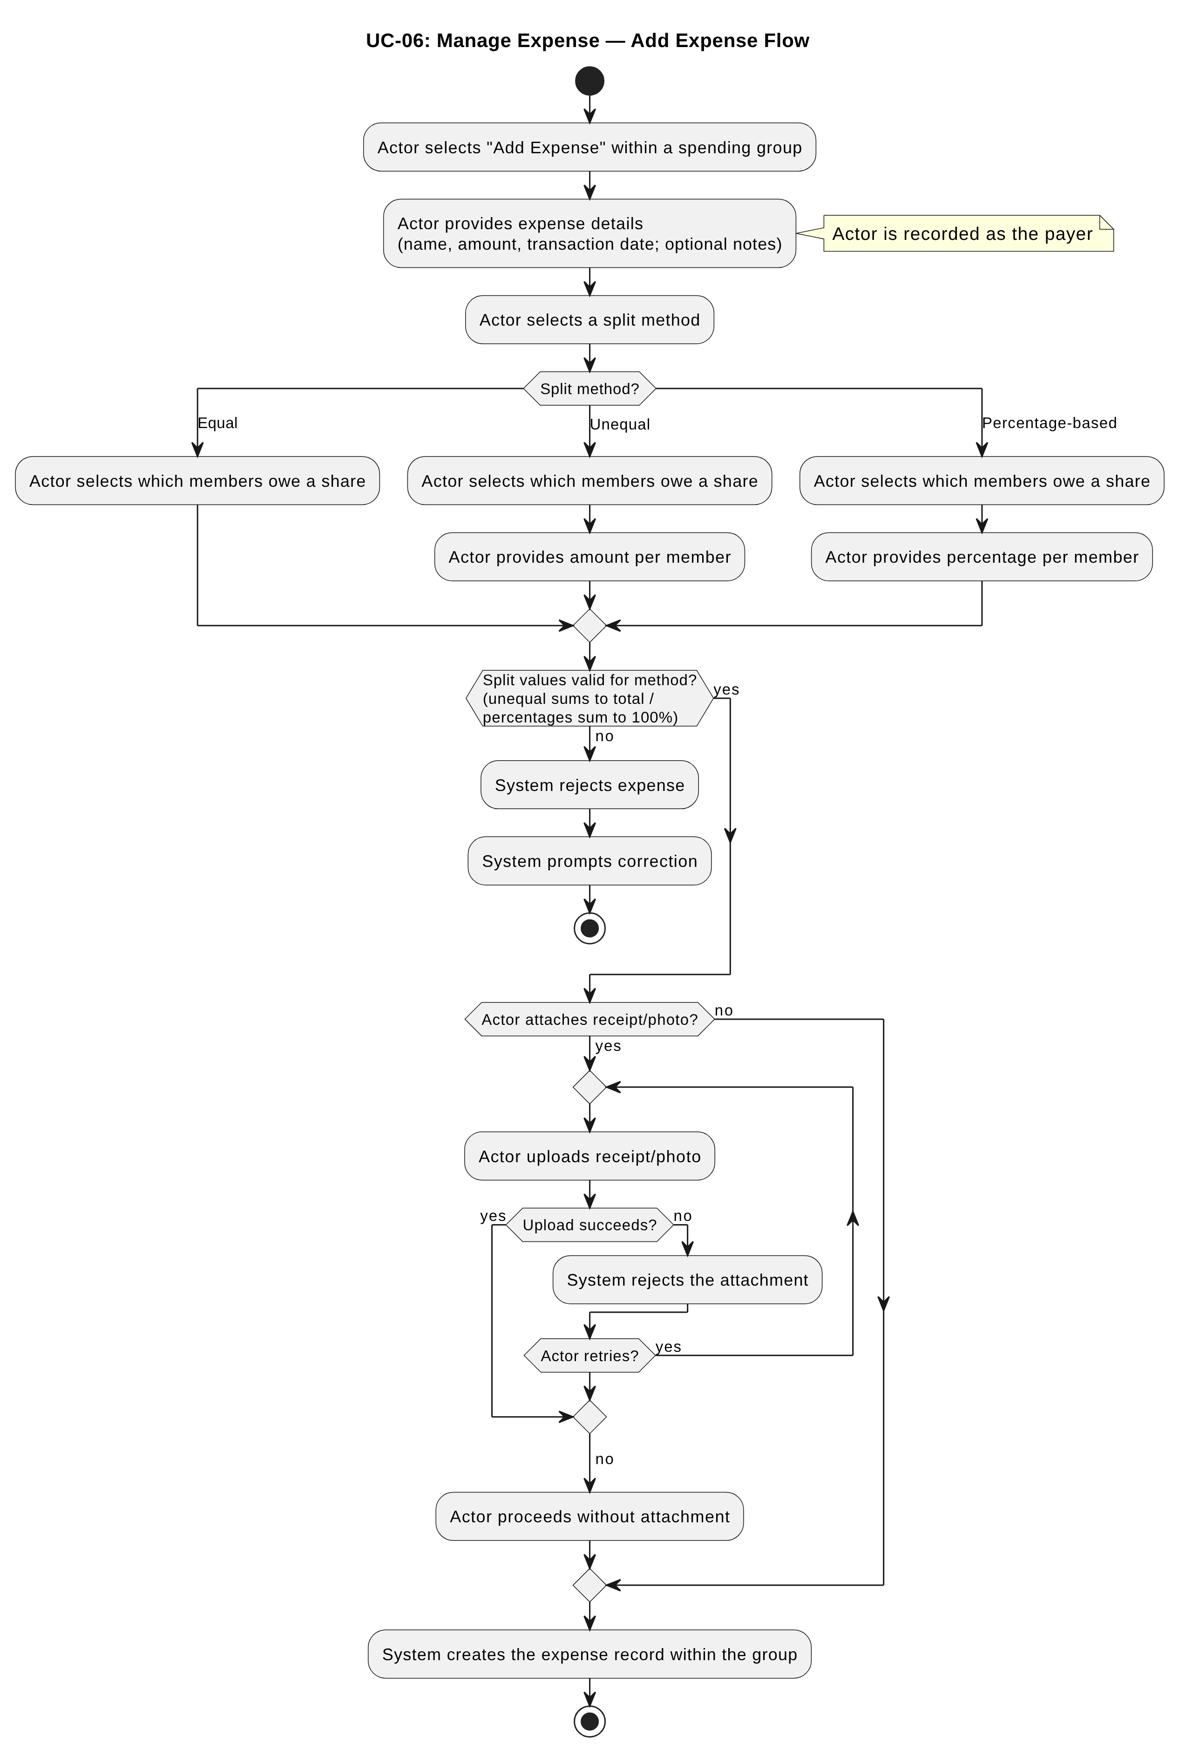
Figure 3: UC-06 Add Expense activity diagram

Alternate Flow — Edit Expense
- Actor selects an existing expense within a spending group
- Actor selects "Edit"
- Actor updates expense details, split method, split values, and/or receipt attachment
- System validates the updated expense and split details
- System saves the updated expense record

Alternate Flow — Delete Expense
- Actor selects an existing expense within a spending group
- Actor selects "Delete"
- System removes the expense record from the group

Alternate Flow — View Expense Details
- Actor selects an existing expense within a spending group
- System displays the expense's details, including payer, split breakdown, and receipt attachment (if any)

Exception Flows
- Actor is not a member of the target group → system denies access
- Split values are invalid for the selected method → system rejects the expense and prompts correction
- Receipt attachment fails to upload → system rejects the attachment, allows actor to retry or proceed without it

Notes
- Any group member may edit or delete any expense in the group — edit/delete is not restricted to the expense's creator.
- The payer of an expense is always the group member who added it; multiple members may owe a share via the split.

UC-07: Manage Recurring Expense
Actor: Group Member
Description: Allows a group member to add, edit, or delete a recurring expense template within a spending group
Preconditions: Actor holds an authenticated session; actor is a member of the target group
Postconditions: Recurring expense template is created/updated/removed within the group; a template past its end date remains editable but stops generating new expenses

Main Flow – Add Recurring Expense
- Actor selects "Add Recurring Expense" within a spending group
- Actor provides expense details: description, amount
- Actor sets a recurrence frequency: weekly (specific day of week), monthly (specific day of month), or a fixed interval of days
- Actor sets a start date (defaults to the current date) and, optionally, an end date
- Actor selects a split method and provides split details, per the same rules as UC-06
- System validates the template and split details
- System creates the recurring expense template within the group
Figure 4 shows the activity diagram for the main flow of UC-07: Add Recurring Expense.
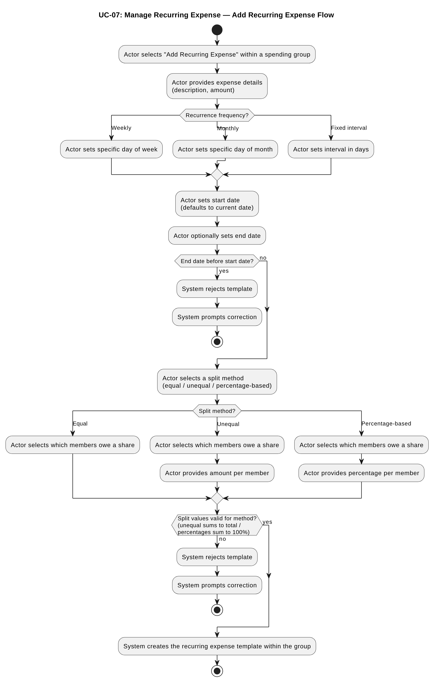
Figure 4: UC-07 Add Recurring Expense activity diagram

Alternate Flow — Edit Recurring Expense
- Actor selects an existing recurring expense template within a spending group
- Actor selects "Edit"
- Actor updates expense details, recurrence frequency, start/end date, split method, and/or split values
- System validates the updated template
- System saves the updated template; future generated expenses reflect the updated configuration, past generated expenses are unaffected

Alternate Flow — Delete Recurring Expense
- Actor selects an existing recurring expense template within a spending group
- Actor selects "Delete"
- System removes the recurring expense template; previously generated expenses are unaffected

Exception Flows
- Actor is not a member of the target group → system denies access
- Split values are invalid for the selected method → system rejects the template and prompts correction
- End date is before start date → system rejects the template and prompts correction

Notes
- A recurring expense is a template used to generate expense instances; editing or deleting a template never retroactively alters expenses already generated (see FR-SYS-03).
- When a monthly recurrence's configured day (e.g. 31) does not exist in a given month (e.g. February, or 30-day months), the system clamps the generation date to the last day of that month.

UC-08: Manage Settlement
Actor: Group Member
Description: Allows a group member to add a settlement record within a spending group, and, for settlements they created, edit, delete, or view its details
Preconditions: Actor holds an authenticated session; actor is a member of the target group; for edit/delete, actor is the creator of the settlement record
Postconditions: Settlement record is created/updated/removed within the group (add/edit/delete); no state change (view)

Main Flow – Add Settlement
- Actor selects "Add Settlement" within a spending group
- Actor specifies the recipient (a group member), amount, and transaction date
- System validates the settlement details
- System creates the settlement record within the group, with the actor recorded as its creator

Alternate Flow — Edit Settlement
- Actor selects an existing settlement record they created within a spending group
- System verifies actor is the settlement's creator
- Actor selects "Edit"
- Actor updates the settlement's recipient, amount, and/or transaction date
- System validates the updated settlement
- System saves the updated settlement record

Alternate Flow — Delete Settlement
- Actor selects an existing settlement record they created within a spending group
- System verifies actor is the settlement's creator
- Actor selects "Delete"
- System removes the settlement record from the group

Alternate Flow — View Settlement Details
- Actor selects an existing settlement record within a spending group
- System displays the settlement's details

Exception Flows
- Actor is not a member of the target group → system denies access
- Actor is not the settlement's creator (edit/delete) → system denies the action
- Amount is zero or negative → system rejects the settlement and prompts correction
- Payer and recipient are the same member → system rejects the settlement and prompts correction

Notes
- The creator of a settlement is also its payer.

UC-09: View Activity
Actor: Group Member
Description: Allows a user to view a list of recent expense and settlement activity across all spending groups they belong to
Preconditions: Actor holds an authenticated session
Postconditions: None (read-only)

Main Flow
- Actor navigates to the activity list
- System retrieves expense create, edit, and delete events across all groups the actor belongs to, regardless of whether the actor is a party to each record
- System retrieves settlement create, edit, and delete events across all groups the actor belongs to, where the actor is a party to the record (payer or recipient)
- System displays each expense event with the acting member, the action taken, the affected group, and the expense's recorded name and total amount at the time of the even
- System displays each settlement event relative to the actor (e.g. "You paid [recipient]" or "[payer] paid you"), with the amount and affected group
- Sy ystem orders the list by event occurrence, most recent first

Exception Flows
- Actor has no qualifying activity → system displays an empty state

Notes
- Expense shows total amount, not personal share.

UC-10: Manage Notification Settings
Actor: User
Description: Allows a user to enable or disable email reminders for unpaid balances
Preconditions: Actor holds an authenticated session
Postconditions: Actor's notification preference is updated

Main Flow
- Actor navigates to notification settings
- Actor toggles email reminders on or off
- System saves the actor's notification preference

Exception Flows
- None identified (single boolean toggle, no invalid states)

Notes
- Reminder frequency is fixed system-wide (once daily, at a fixed system-defined time) and is not user-configurable at this time — see FR-SYS-01.

Data Model
Figure 5 shows the entity-relationship diagram (ERD) for SplitSync.
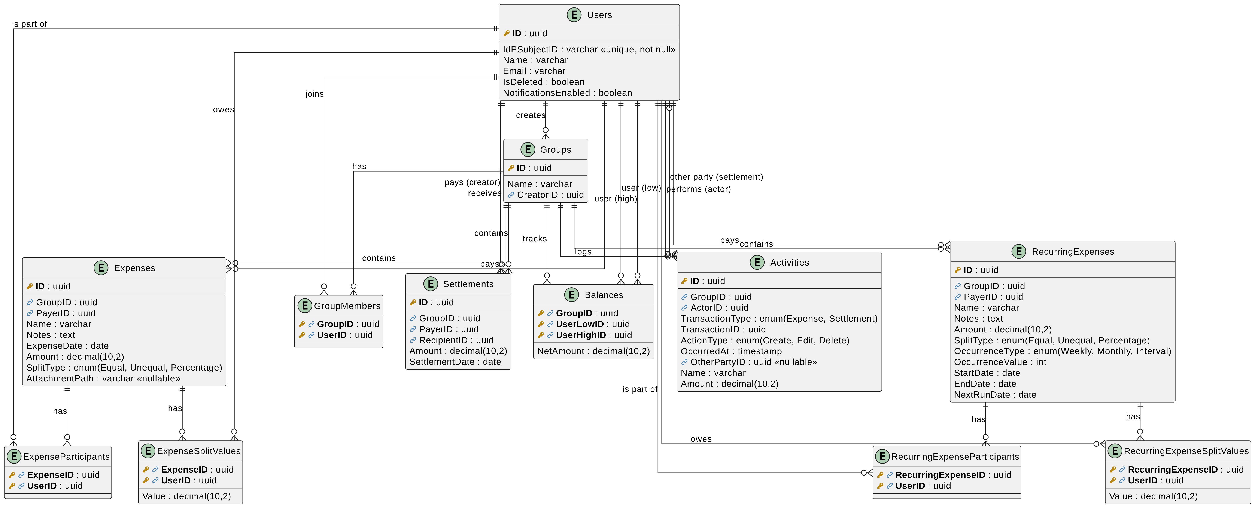
Figure 5: SplitSync entity-relationship diagram (ERD)

Acceptance Criteria
Table 2: Acceptance criteria
AC ID | UC ID | Given | When | Then
AC-UC01-01 | UC-01 | A user selects a supported sign-in method (email/password or Google) with valid credentials | The user submits account creation | The system shall create a new account linked to the verified identity and establish an authenticated session
AC-UC01-02 | UC-01 | A user selects Google sign-in and the associated Google account has no verified email | The user attempts to create an account | The system shall reject account creation and prompt the user to use email/password instead
AC-UC01-03 | UC-01 | A user has an existing account | The user logs in with valid credentials via a supported sign-in method | The system shall establish an authenticated session for the user
AC-UC01-04 | UC-01 | A user submits invalid or unverifiable credentials | The user attempts to log in | The system shall deny access and return the user to the sign-in prompt
AC-UC01-05 | UC-01 | A user holds an authenticated session | The user selects "Log Out" | The system shall terminate the session
AC-UC01-06 | UC-01 | A user has no unpaid balance in any group | The user deletes their account | The system shall remove their personal information and anonymize their historical records
AC-UC01-07 | UC-01 | A user has an unpaid balance in one or more groups | The user attempts to delete their account | The system shall reject the deletion
AC-UC02-01 | UC-02 | An authenticated user provides valid group details | The user creates a spending group | The system shall create the group with the user recorded as creator and as its first member
AC-UC02-02 | UC-02 | A group's creator provides updated group details | The creator edits the group | The system shall save the updated details
AC-UC02-03 | UC-02 | A user who is not the group's creator | The user attempts to edit the group | The system shall deny the action
AC-UC02-04 | UC-02 | A group's creator initiates group deletion | The deletion is confirmed | The system shall remove the group and its associated data, regardless of any unpaid balances between members
AC-UC02-05 | UC-02 | A user who is not the group's creator | The user attempts to delete the group | The system shall deny the action
AC-UC02-06 | UC-02 | A group's creator specifies a user to add | The creator adds the member | The system shall add the specified user to the group
AC-UC02-07 | UC-02 | A user who is not the group's creator | The user attempts to add a member | The system shall deny the action
AC-UC02-08 | UC-02 | A target member has no unpaid balance in the group | The group's creator removes that member | The system shall remove the member from the group
AC-UC02-09 | UC-02 | A target member has an unpaid balance in the group | The group's creator attempts to remove that member | The system shall reject the removal
AC-UC02-10 | UC-02 | A user who is not the group's creator | The user attempts to remove a member | The system shall deny the action
AC-UC02-11 | UC-02 | A user is the creator of a spending group | The creator attempts to remove themselves from the group | The system shall deny the action, as creator self-removal is out of scope
AC-UC03-01 | UC-03 | An authenticated user is a member of one or more spending groups | The user navigates to the group list view | The system shall display all spending groups the user is a member of
AC-UC03-02 | UC-03 | An authenticated user is not a member of any spending group | The user navigates to the group list view | The system shall display an empty state
AC-UC03-03 | UC-03 | An authenticated user is a member of some spending groups but not others | The user navigates to the group list view | The system shall display only the groups the user is a member of, and shall not display groups the user does not belong to
AC-UC04-01 | UC-04 | An authenticated group member has balances with other members in a spending group | The member views the group's balance | The system shall display each balance directly involving the member (amounts owed to others, and amounts owed to the member)
AC-UC04-02 | UC-04 | An authenticated group member has no balance with any other member in a spending group | The member views the group's balance | The system shall display an empty or zero state
AC-UC04-03 | UC-04 | A user is not a member of the target spending group | The user attempts to view that group's balance | The system shall deny access
AC-UC04-04 | UC-04 | A spending group has a balance between two members that does not involve the requesting member | The requesting member views the group's balance | The system shall not display that balance
AC-UC05-01 | UC-05 | A spending group has one or more expenses and settlements | An authenticated group member views the group's transactions | The system shall display the combined list of expenses and settlements, ordered by transaction date descending
AC-UC05-02 | UC-05 | A spending group has no expenses or settlements | An authenticated group member views the group's transactions | The system shall display an empty state
AC-UC05-03 | UC-05 | A user is not a member of the target spending group | The user attempts to view that group's transactions | The system shall deny access
AC-UC05-04 | UC-05 | An expense or settlement has a transaction date different from its creation timestamp | A group member views the group's transactions | The system shall order the list by transaction date, not creation timestamp
AC-UC06-01 | UC-06 | An authenticated group member provides valid expense details and a split (equal, unequal, or percentage) that satisfies the split's validation rule | The member adds the expense | The system shall create the expense record with the member recorded as payer
AC-UC06-02 | UC-06 | An unequal split where the specified amounts do not sum to the expense total | The member submits the expense | The system shall reject the expense and prompt for correction
AC-UC06-03 | UC-06 | A percentage-based split where the specified percentages do not sum to 100% | The member submits the expense | The system shall reject the expense and prompt for correction
AC-UC06-09 | UC-06 | An equal split where the expense total does not divide evenly among members (e.g. $10 split three ways) | The member submits the expense | The system shall calculate split amounts to 2 decimal places and allocate any rounding remainder sequentially to the first listed member(s), such that split amounts sum exactly to the total
AC-UC06-04 | UC-06 | A group member attaches a receipt/photo to an expense and the upload succeeds | The expense is saved | The system shall store the attachment with the expense record
AC-UC06-05 | UC-06 | A receipt/photo upload fails | The member submits the expense | The system shall reject the attachment and allow the member to retry or proceed without it
AC-UC06-06 | UC-06 | Any group member (not necessarily the expense's original payer) | That member edits or deletes an existing expense in the group | The system shall allow the action
AC-UC06-07 | UC-06 | A user who is not a member of the target group | The user attempts to add, edit, delete, or view an expense in that group | The system shall deny access
AC-UC06-08 | UC-06 | An existing expense | A group member views its details | The system shall display the payer, split breakdown, and receipt attachment (if any)
AC-UC07-01 | UC-07 | Valid expense details, a recurrence frequency, and a start date | A group member creates a recurring expense template | The system shall create the template within the group
AC-UC07-02 | UC-07 | A recurring expense template with an end date set before its start date | The member submits the template | The system shall reject the template and prompt for correction
AC-UC07-03 | UC-07 | A recurring expense template with invalid split values | The member submits the template | The system shall reject the template and prompt for correction
AC-UC07-04 | UC-07 | An existing recurring expense template | A group member edits it | The system shall save the updated configuration, and expenses already generated from the template shall remain unaffected
AC-UC07-05 | UC-07 | An existing recurring expense template | A group member deletes it | The system shall remove the template, and expenses already generated from it shall remain unaffected
AC-UC07-06 | UC-07 | A recurring expense template whose end date has passed | The system evaluates the template for expense generation | The system shall not generate a new expense from it, and the template shall remain visible and editable
AC-UC07-07 | UC-07 | A recurring expense template configured for monthly recurrence on a day that does not exist in the current month (e.g. day 31 in a 30-day month, or day 29/30/31 in February) | The system evaluates the template for expense generation | The system shall generate the expense on the last valid day of that month
AC-UC07-08 | UC-07 | A recurring expense template that was clamped to a shorter month's last day | The system evaluates the template for a subsequent month that does contain the configured day | The system shall generate the expense on the originally configured day, not the clamped date
AC-UC08-01 | UC-08 | A valid recipient, amount greater than zero, and transaction date | A group member adds a settlement | The system shall create the settlement record with the member recorded as its creator, who is also recorded as the payer
AC-UC08-02 | UC-08 | A settlement amount of zero or a negative value | The member submits the settlement | The system shall reject the settlement and prompt for correction
AC-UC08-03 | UC-08 | A settlement where the recipient is the same as the acting member | The member submits the settlement | The system shall reject the settlement and prompt for correction
AC-UC08-04 | UC-08 | A settlement record created by a group member | That member edits or deletes the settlement | The system shall allow the action
AC-UC08-05 | UC-08 | A settlement record created by another group member | A non-creator member attempts to edit or delete it | The system shall deny the action
AC-UC08-06 | UC-08 | An existing settlement record | A group member views its details | The system shall display the settlement's details
AC-UC09-01 | UC-09 | An expense create, edit, or delete event in a group the member belongs to | The member views their activity list | The system shall display the event, including the acting member, the action taken, the affected group, the expense's name and amount
AC-UC09-02 | UC-09 | A settlement create, edit, or delete event where the member is the payer or recipient | The member views their activity list | The system shall display the event as "You paid [recipient]" or "[recipient] paid you" with the amount and affected group
AC-UC09-03 | UC-09 | A group member has no qualifying activity across any of their groups | The member views their activity list | The system shall display an empty state
AC-UC09-04 | UC-09 | Multiple qualifying activity events across different groups | A member views their activity list | The system shall order the events by occurrence, most recent first
AC-UC09-05 | UC-09 | A settlement event where the member is not the payer or recipient | The member views their activity list | The system shall not display that event
AC-UC10-01 | UC-10 | An authenticated user | The user enables email reminders | The system shall save the preference and the user shall receive the daily reminder email described in FR-SYS-01 while unpaid balances exist
AC-UC10-02 | UC-10 | An authenticated user | The user disables email reminders | The system shall save the preference and the user shall not receive reminder emails

Non-Functional Requirements

Table 3: Non-functional requirements
NFR ID | Category | Requirement | Verification Method
NFR-PERF-01 | Performance | The system's API shall have an average response time of under 200ms | Load testing (e.g. k6/Artillery)
NFR-PERF-02 | Performance | The system's full-page load shall have an average finish time of under 2s | Automated tool (Lighthouse)
NFR-PERF-03 | Performance | The system's in-page interaction shall have an average finish time of under 200ms, unless the element requires an API request | Manual QA test (browser devtools)
NFR-SEC-01 | Security | The system shall validate and sanitise all user inputs before use | Manual QA test / code review
NFR-SEC-02 | Security | The system shall be protected against the vulnerability categories defined in the current OWASP Top 10 | Tools (OWASP ZAP)
NFR-SEC-03 | Security | The system shall ensure that all communication between system and user is encrypted via HTTPS | Manual verification (certificate/connection check)
NFR-SEC-04 | Security | The system shall implement role-based access control with fine-grained permissions for each user, to properly limit access to resources | Manual QA test
NFR-REL-01 | Reliability | The system shall have at least 99% of requests succeed under normal operation | Load testing (e.g. k6/Artillery)
NFR-REL-02 | Reliability | The system shall have at least 99% success rate during a load test of 100 concurrent requests | Load testing (e.g. k6/Artillery)
NFR-REL-03 | Reliability | The system's response time shall be under 500ms under a peak load of 100 concurrent requests | Load testing (e.g. k6/Artillery)
NFR-COMPAT-01 | Compatibility | The system's core functionality shall be accessible on any browser supporting the PWA/Service Worker standard on mobile devices | Manual QA test (multi-browser)
NFR-MAINT-01 | Maintainability | The system's dependencies shall contain no packages flagged as deprecated or containing known critical vulnerabilities at time of release | Automated tool (dotnet list package --deprecated/--vulnerable, npm audit)
NFR-USAB-01 | Usability | The system's UI shall achieve a Lighthouse Accessibility score of at least 90 | Automated tool (Lighthouse)
NFR-USAB-02 | Usability | The system's UI shall render without horizontal scrolling or overlapping elements at viewport widths from 360px to 1920px | Manual QA test (browser devtools resize)
NFR-LEGAL-01 | Legal | The system shall allow permanent deletion of a registered user's information | Manual QA test (traces to UC-01 Delete Account)

Traceability Matrix

Table 4: Traceability matrix
FR ID | Category | Linked UC ID | Linked AC ID(s)
FR-AUTH-01 | Authentication | UC-01 | AC-UC01-01
FR-AUTH-02 | Authentication | UC-01 | AC-UC01-03, AC-UC01-04
FR-AUTH-03 | Authentication | UC-01 | AC-UC01-05
FR-GROUP-01 | Spending Group | UC-02 | AC-UC02-01
FR-GROUP-02 | Spending Group | UC-02 | AC-UC02-04, AC-UC02-05
FR-GROUP-03 | Spending Group | UC-02 | AC-UC02-02, AC-UC02-03
FR-GROUP-04 | Spending Group | UC-02 | AC-UC02-06, AC-UC02-07
FR-GROUP-05 | Spending Group | UC-02 | AC-UC02-08, AC-UC02-09, AC-UC02-10, AC-UC02-11
FR-GROUP-06 | Spending Group | UC-03 | AC-UC03-01, AC-UC03-02, AC-UC03-03
FR-GROUP-07 | Spending Group | UC-04 | AC-UC04-01, AC-UC04-02, AC-UC04-03, AC-UC04-04
FR-GROUP-08 | Spending Group | UC-05 | AC-UC05-01, AC-UC05-02, AC-UC05-03, AC-UC05-04
FR-EXP-01 | Expense | UC-06 | AC-UC06-01, AC-UC06-02, AC-UC06-03, AC-UC06-07
FR-EXP-02 | Expense | UC-06 | AC-UC06-06, AC-UC06-07
FR-EXP-03 | Expense | UC-06 | AC-UC06-06, AC-UC06-07
FR-EXP-04 | Expense | UC-06 | AC-UC06-08
FR-EXP-05 | Expense | UC-06 | AC-UC06-01, AC-UC06-02, AC-UC06-03
FR-EXP-06 | Expense | UC-06 | AC-UC06-04, AC-UC06-05
FR-EXP-07 | Expense | UC-07 | AC-UC07-01, AC-UC07-02, AC-UC07-03
FR-EXP-08 | Expense | UC-07 | AC-UC07-04
FR-EXP-09 | Expense | UC-07 | AC-UC07-05
FR-SETL-01 | Settlement | UC-08 | AC-UC08-01, AC-UC08-02, AC-UC08-03
FR-SETL-02 | Settlement | UC-08 | AC-UC08-04, AC-UC08-05
FR-SETL-03 | Settlement | UC-08 | AC-UC08-04, AC-UC08-05
FR-SETL-04 | Settlement | UC-08 | AC-UC08-06
FR-ACT-01 | Activity | UC-09 | AC-UC09-01, AC-UC09-02, AC-UC09-03, AC-UC09-04, AC-UC09-05
FR-NOTIF-01 | Notification | UC-10 | AC-UC10-01, AC-UC10-02
FR-SYS-01 | System | N/A (system-triggered; see UC-10) | AC-UC10-01
FR-SYS-02 | System | N/A (system-triggered; see UC-02) | AC-UC02-09
FR-SYS-03 | System | N/A (system-triggered; see UC-07) | AC-UC07-06, AC-UC07-07, AC-UC07-08

